**Contain Duplicates II – use a map**

**Flatten 2D Vector**

Cur记录当前指向的是第几个arr的iterator

记住：每次call next：

1.返回当前指针指向的

2.把指针挪到下一个位置

hasnext：判断当前指针指向的位置有没有合法元素

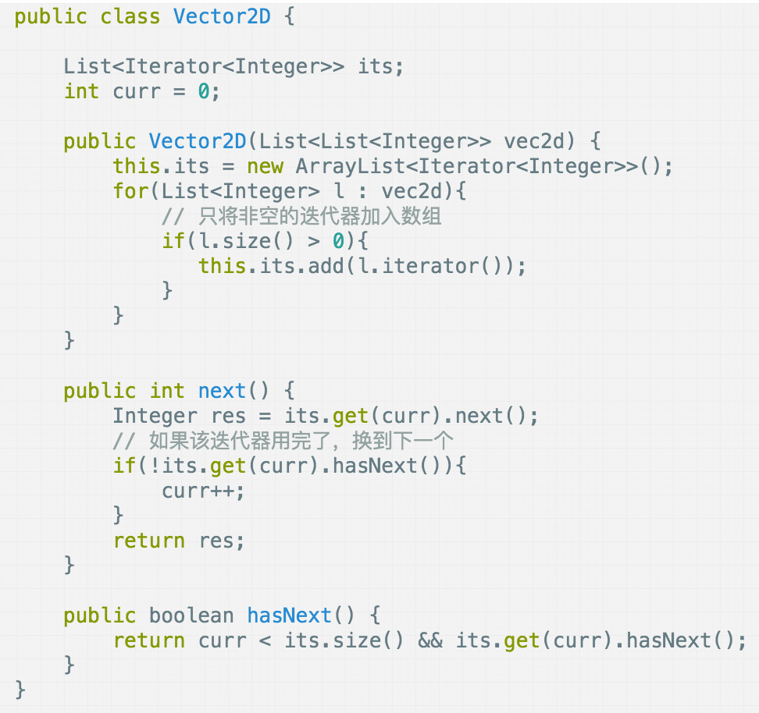

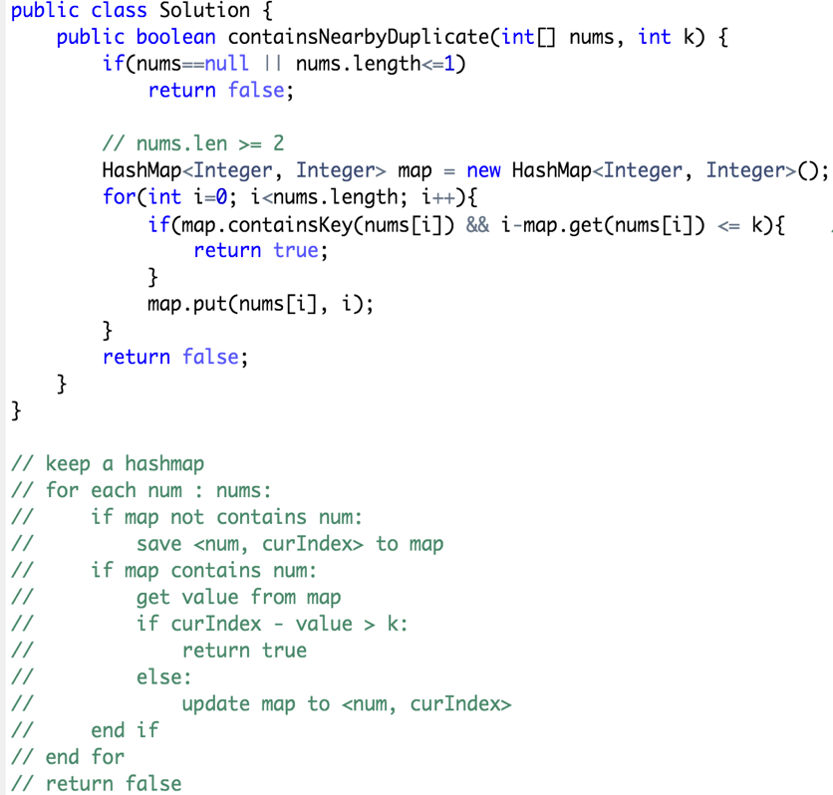

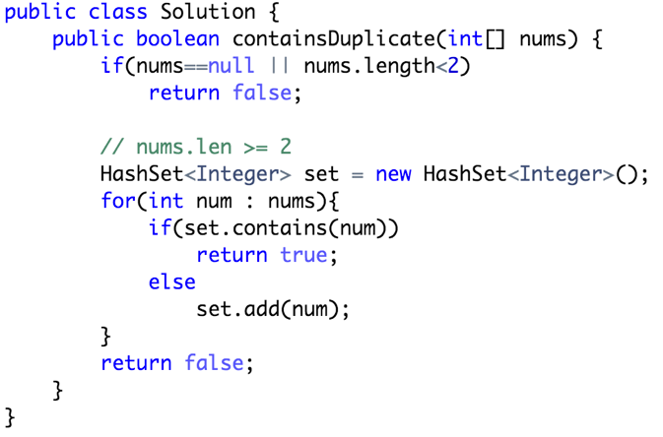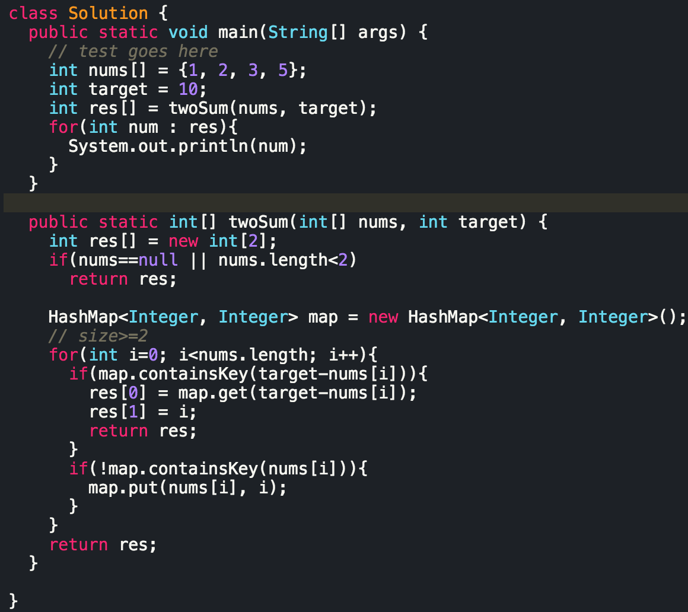

**Contain Duplicates I**

**use a set**

**Two Sum**

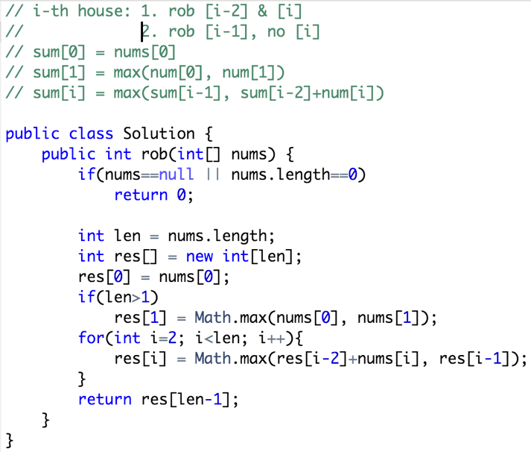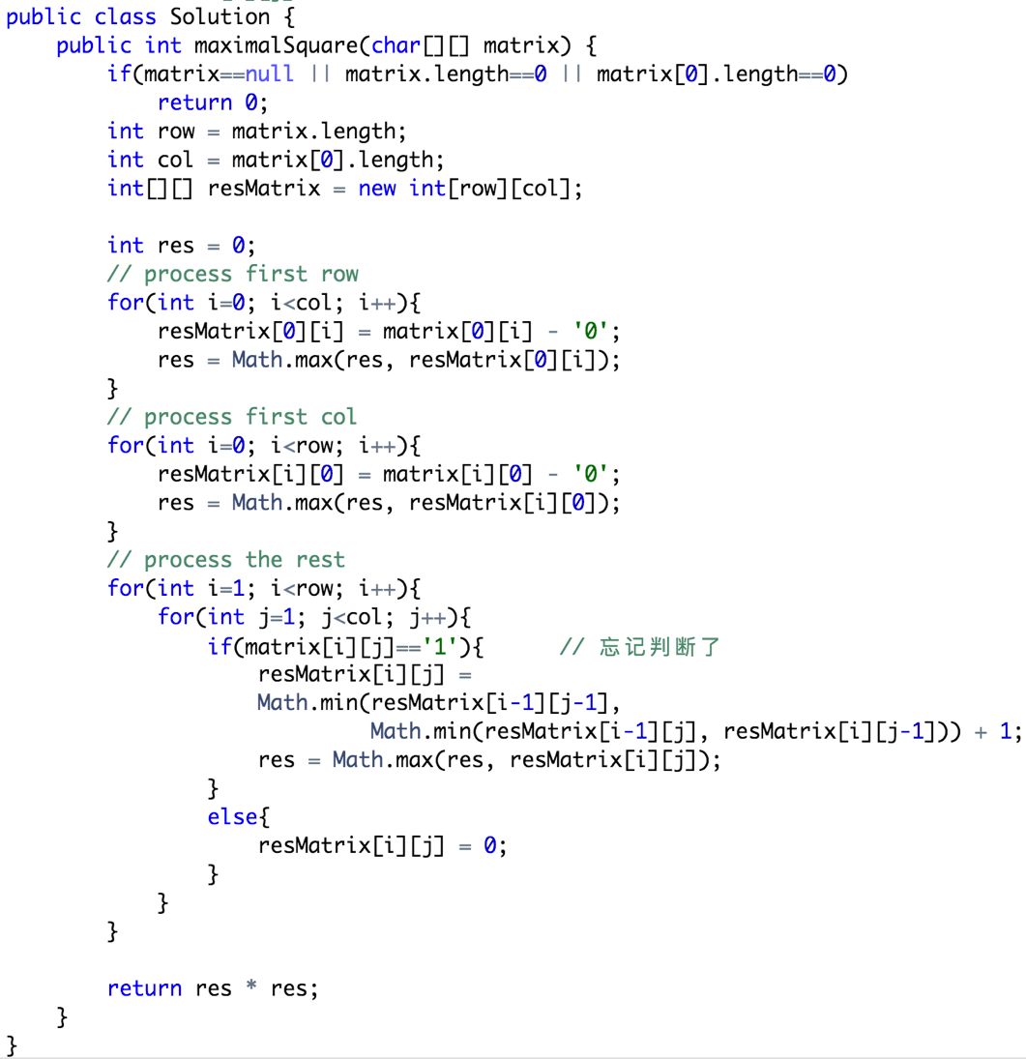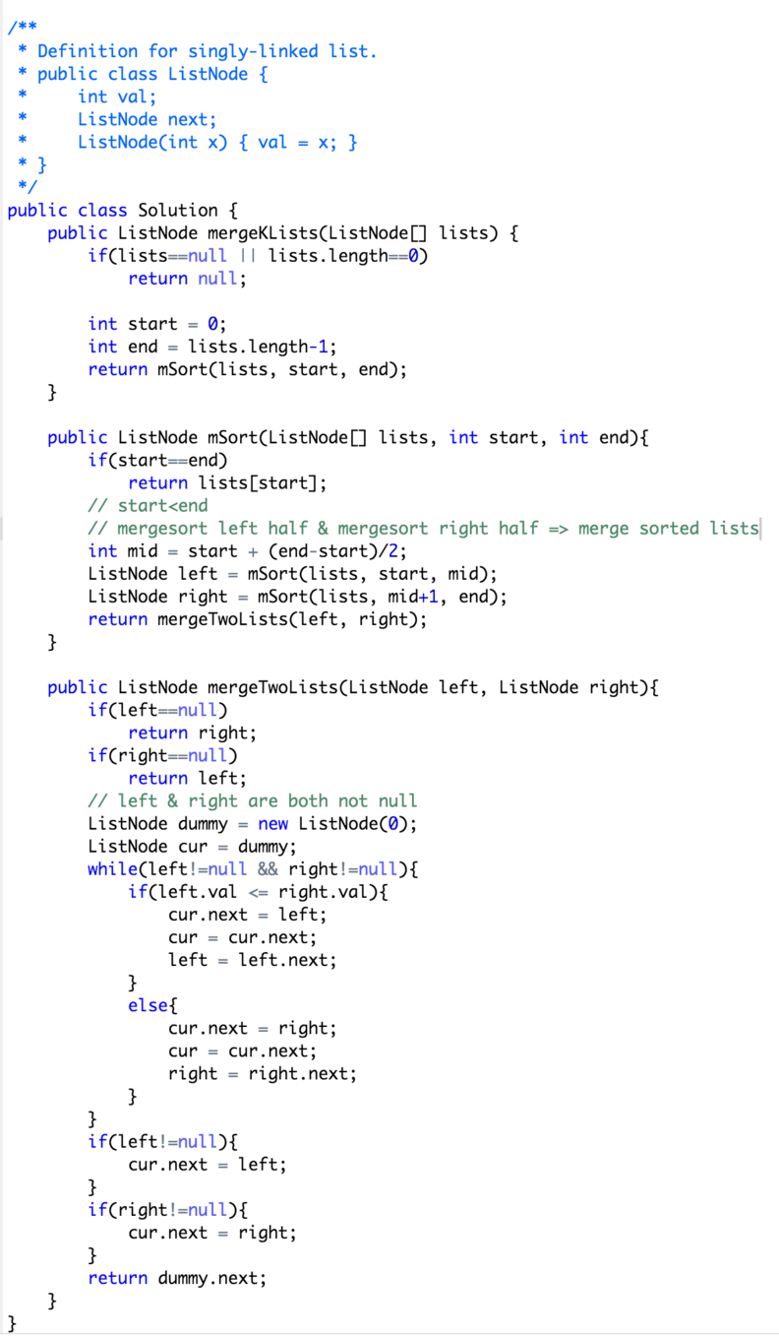

**House Robber I**

**Merge K sorted lists**

**Maximal Square**

**House Robber II**

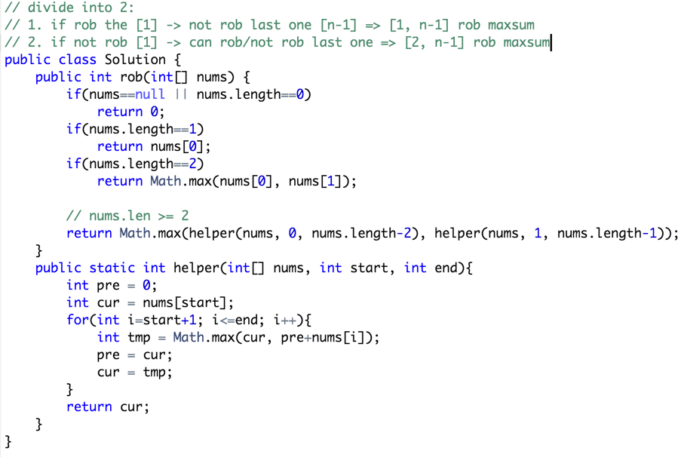

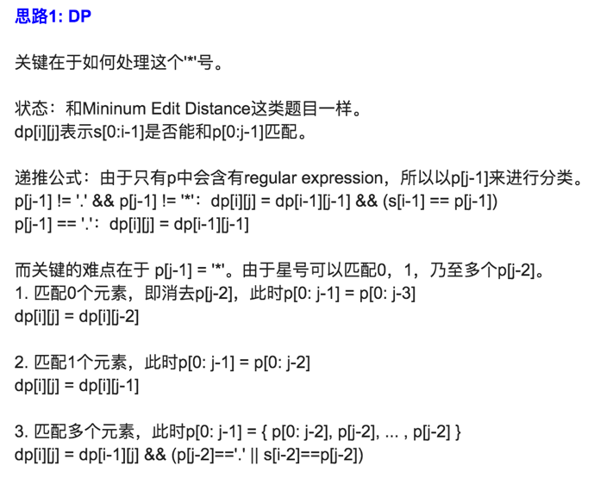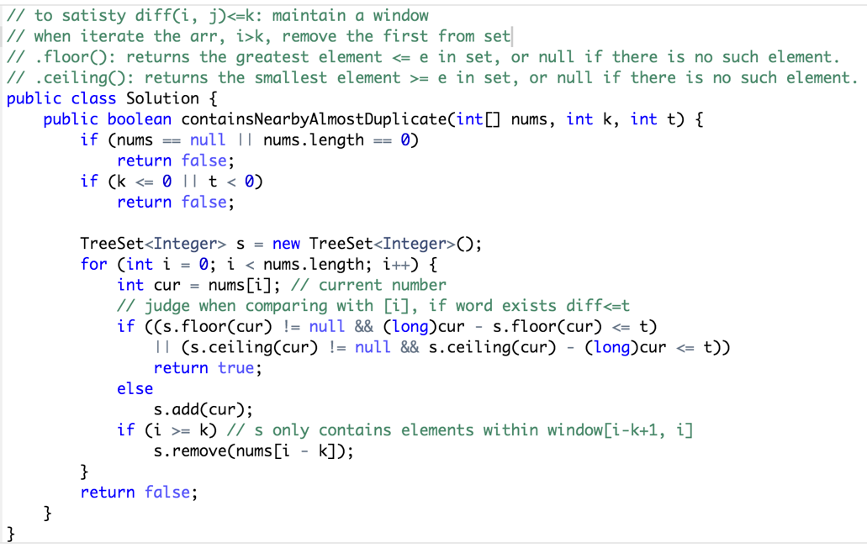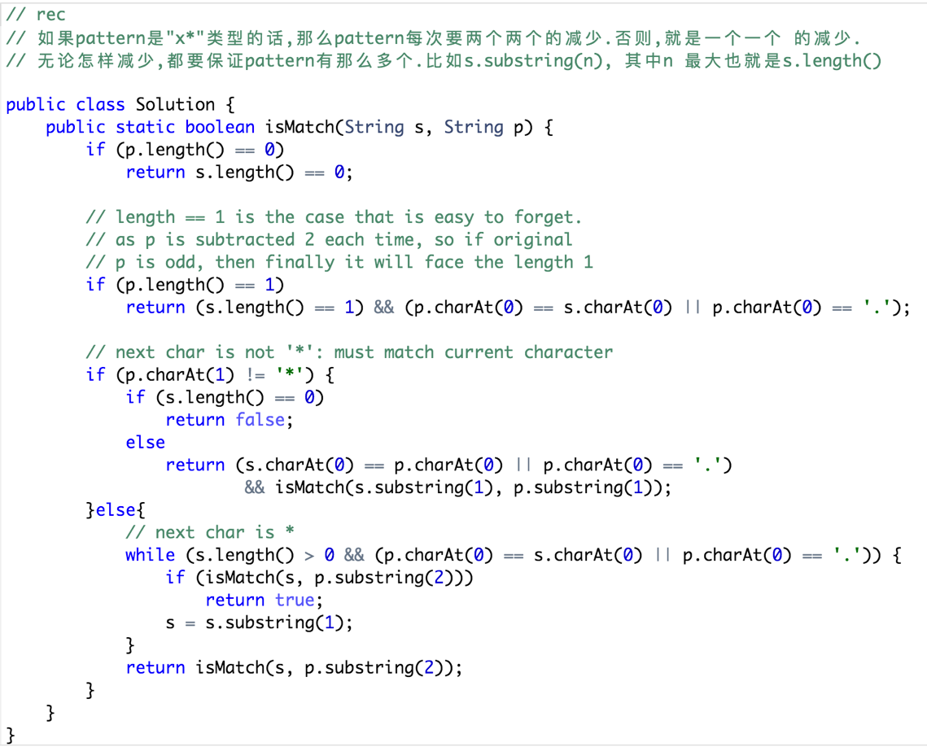

**Regular Expression Matching**

**Contain Duplicates III**

**Text Justification**



**Word Search II**

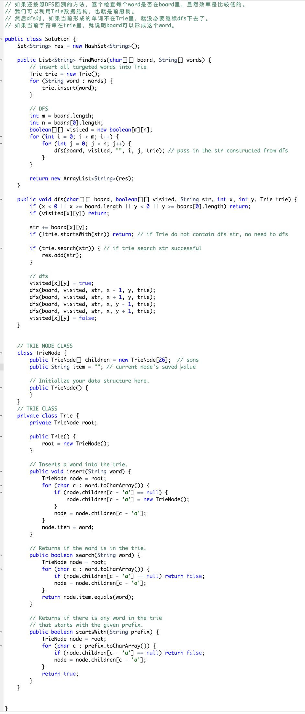

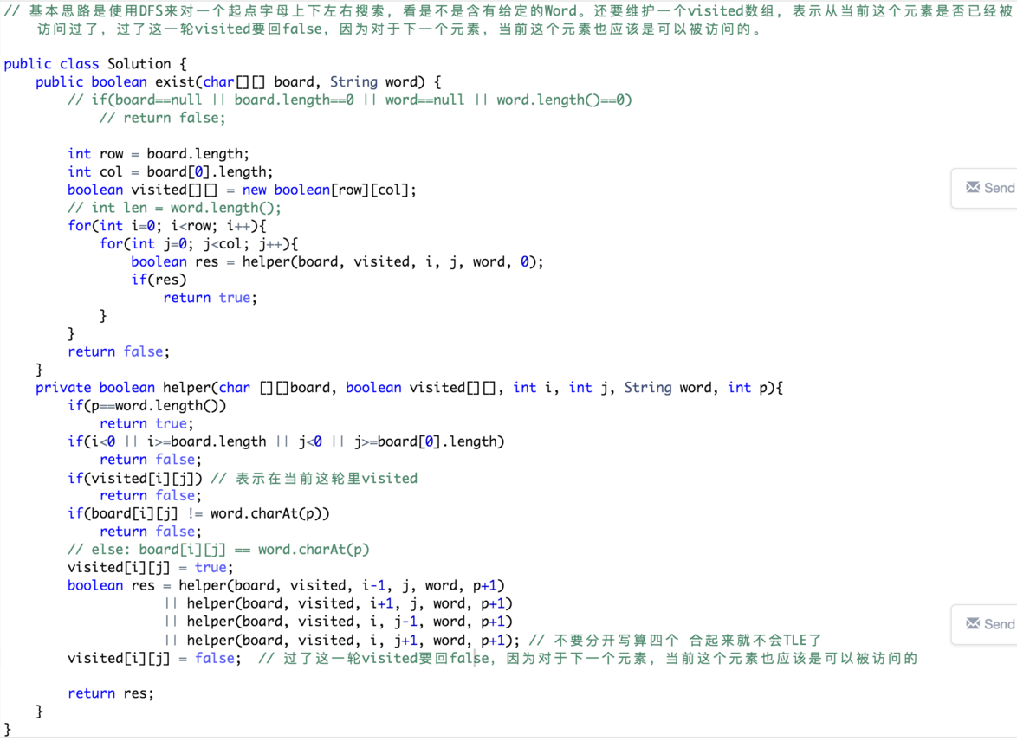

**Word Search**

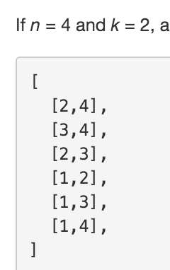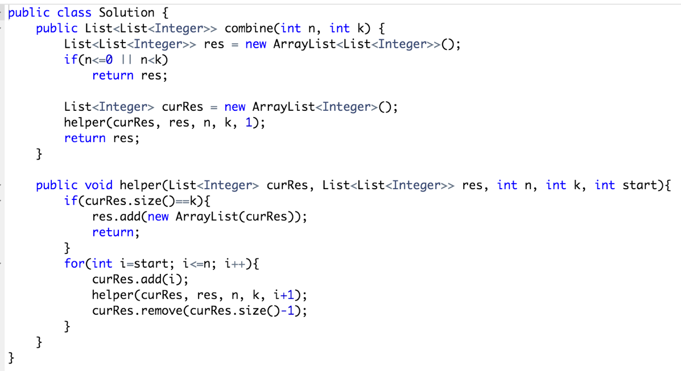**Subsets**

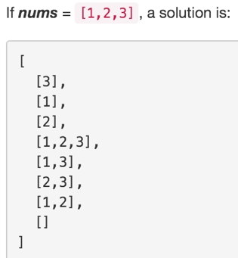

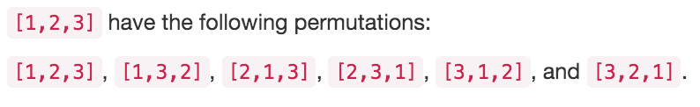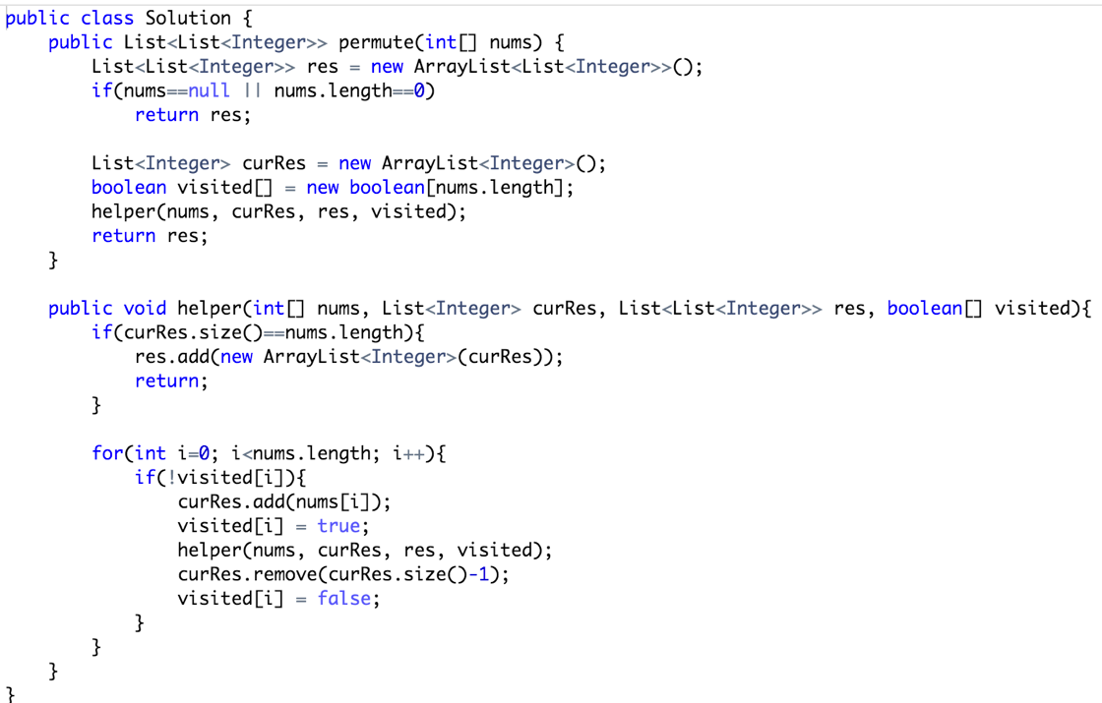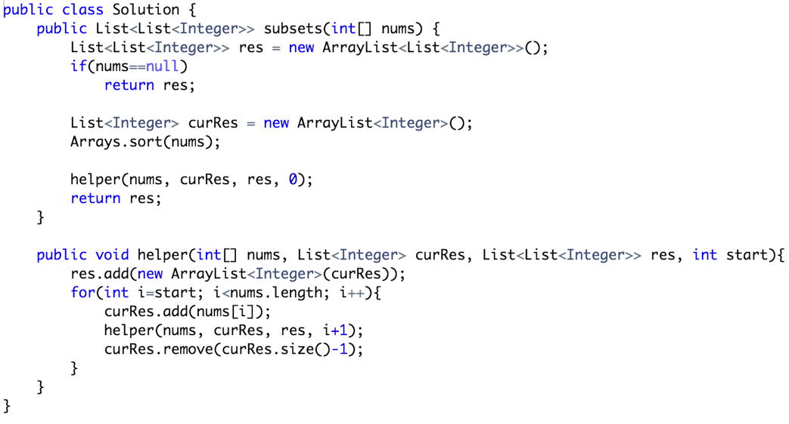

**Permutations**

**Combinations**

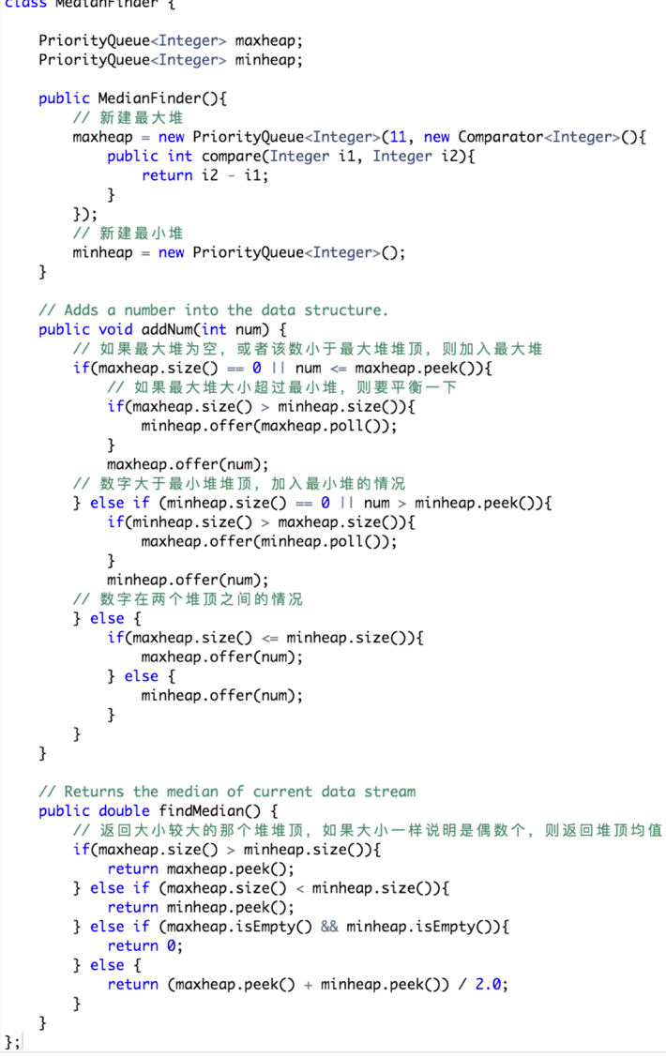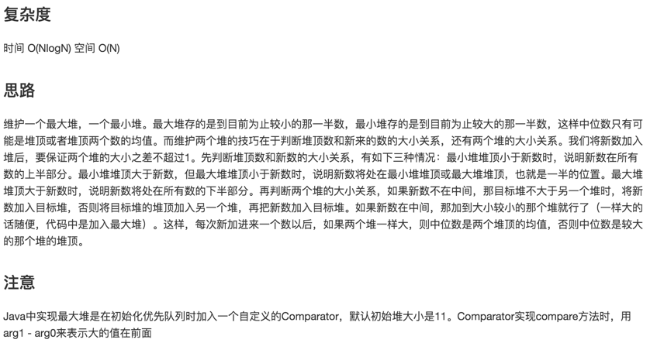

**Find Median in Data Stream**

Alien Dictionary

public class Solution {

public String alienOrder(String[] words) {

// 节点构成的图

Map<Character, Set<Character>> graph = new HashMap<Character, Set<Character>>();

// 节点的计数器

Map<Character, Integer> indegree = new HashMap<Character, Integer>();

// 结果存在这个里面

StringBuilder order = new StringBuilder();

// 初始化图和计数器

initialize(words, graph, indegree);

// 建图并计数

buildGraphAndGetIndegree(words, graph, indegree);

// 拓扑排序的最后一步，根据计数器值广度优先搜索

topologicalSort(order, graph, indegree);

// 如果大小相等说明无环

return order.length() == indegree.size() ? order.toString() : "";

}

private void initialize(String[] words, Map<Character, Set<Character>> graph, Map<Character, Integer> indegree){

for(String word : words){

for(int i = 0; i < word.length(); i++){

char curr = word.charAt(i);

// 对每个单词的每个字母初始化计数器和图节点

if(graph.get(curr) == null){

graph.put(curr, new HashSet<Character>());

}

if(indegree.get(curr) == null){

indegree.put(curr, 0);

}

}

}

}

private void buildGraphAndGetIndegree(String[] words, Map<Character, Set<Character>> graph, Map<Character, Integer> indegree){

Set<String> edges = new HashSet<String>();

for(int i = 0; i < words.length - 1; i++){

// 每两个相邻的词进行比较

String word1 = words[i];

String word2 = words[i + 1];

for(int j = 0; j < word1.length() && j < word2.length(); j++){

char from = word1.charAt(j);

char to = word2.charAt(j);

// 如果相同则继续，找到两个单词第一个不相同的字母

if(from == to) continue;

// 如果这两个字母构成的边还没有使用过，则

if(!edges.contains(from+""+to)){

Set<Character> set = graph.get(from);

set.add(to);

// 将后面的字母加入前面字母的Set中

graph.put(from, set);

Integer toin = indegree.get(to);

toin++;

// 更新后面字母的计数器，+1

indegree.put(to, toin);

// 记录这条边已经处理过了

edges.add(from+""+to);

break;

}

}

}

}

private void topologicalSort(StringBuilder order, Map<Character, Set<Character>> graph, Map<Character, Integer> indegree){

// 广度优先搜索的队列

Queue<Character> queue = new LinkedList<Character>();

// 将有向图的根，即计数器为0的节点加入队列中

for(Character key : indegree.keySet()){

if(indegree.get(key) == 0){

queue.offer(key);

}

}

// 搜索

while(!queue.isEmpty()){

Character curr = queue.poll();

// 将队头节点加入结果中

order.append(curr);

Set<Character> set = graph.get(curr);

if(set != null){

// 对所有该节点指向的节点，更新其计数器，-1

for(Character c : set){

Integer val = indegree.get(c);

val--;

// 如果计数器归零，则加入队列中待处理

if(val == 0){

queue.offer(c);

}

indegree.put(c, val);

}

}

}

}

}

新建一个AlienChar数据结构重写，只用一个Map作为Graph自身

public class Solution {

public String alienOrder(String[] words) {

Map<Character, AlienChar> graph = new HashMap<Character, AlienChar>();

// 如果建图失败，比如有a->b和b->a这样的边，就返回false

boolean isBuildSucceed = buildGraph(words, graph);

if(!isBuildSucceed){

return "";

}

// 在建好的图中根据拓扑排序遍历

String order = findOrder(graph);

return order.length() == graph.size() ? order : "";

}

private boolean buildGraph(String[] words, Map<Character, AlienChar> graph){

HashSet<String> visited = new HashSet<String>();

// 初始化图，每个字母都初始化入度为0

initializeGraph(words, graph);

for(int wordIdx = 0; wordIdx < words.length - 1; wordIdx++){

String before = words[wordIdx];

String after = words[wordIdx + 1];

Character prev = null, next = null;

// 找到相邻两个单词第一个不一样的字母

for(int letterIdx = 0; letterIdx < before.length() && letterIdx < after.length(); letterIdx++){

if(before.charAt(letterIdx) != after.charAt(letterIdx)){

prev = before.charAt(letterIdx);

next = after.charAt(letterIdx);

break;

}

}

// 如果有环，则建图失败

if(prev != null && visited.contains(next + "" + prev)){

return false;

}

// 如果这条边没有添加过，则在图中加入这条边

if(prev != null && !visited.contains(prev + "" + next)){

addEdge(prev, next, graph);

visited.add(prev + "" + next);

}

}

return true;

}

private void initializeGraph(String[] words, Map<Character, AlienChar> graph){

for(String word : words){

for(int idx = 0; idx < word.length(); idx++){

if(!graph.containsKey(word.charAt(idx))){

graph.put(word.charAt(idx), new AlienChar(word.charAt(idx)));

}

}

}

}

private void addEdge(char prev, char next, Map<Character, AlienChar> graph){

AlienChar prevAlienChar = graph.get(prev);

AlienChar nextAlienChar = graph.get(next);

nextAlienChar.indegree += 1;

prevAlienChar.later.add(nextAlienChar);

graph.put(prev, prevAlienChar);

graph.put(next, nextAlienChar);

}

private String findOrder(Map<Character, AlienChar> graph){

StringBuilder order = new StringBuilder();

Queue<AlienChar> queue = new LinkedList<AlienChar>();

for(Character c : graph.keySet()){

if(graph.get(c).indegree == 0){

queue.offer(graph.get(c));

}

}

while(!queue.isEmpty()){

AlienChar curr = queue.poll();

order.append(curr.val);

for(AlienChar next : curr.later){

if(--next.indegree == 0){

queue.offer(next);

}

}

}

return order.toString();

}

}

class AlienChar {

char val;

ArrayList<AlienChar> later;

int indegree;

public AlienChar(char c){

this.val = c;

this.later = new ArrayList<AlienChar>();

this.indegree = 0;

}

}